

DVTK Design Specification
DVT GUI

1.0
2005-06-29

Table of Contents
1 Introduction 3
1.1 Purpose 3
1.2 Scope 3
1.3 Audience 3
1.4 Abbreviations and acronyms 3
1.5 References 3
1.6 History 3
2 Global Design of DVT GUI 4
2.1 General 4
2.2 GUI Layout 4
2.3 The main classes of DVT GUI 5
2.3.1 MainForm Class 5
2.3.2 ProjectForm Class 6
2.3.3 SessionTreeViewManager Class 8
2.3.4 SOP Class Manager Class 10
2.3.5 ValidationResultManager Class 11
2.3.6 ResultsFile Class 12
2.3.7 Project Class 13
2.3.8 EventType Class 14
2.3.9 WizardNew Class 15
2.3.10 CustomExceptionHandler Class 16
2.3.11 UserSettings Class 16
2.3.12 NodeInformation Class 17
2.3.13 PathUtils Class 17
3 DVT Command Tool 18
3.1 Design of DVT command tool 18

Introduction

Purpose
This document describes the global and detail design of the DVT GUI. This is a living document and changes in the design should be laid down in this document.

Scope
The DVT GUI is a Windows Form based application.

Audience
This document is intended for all the implementers in the DVT project. The reader is assumed to have basic DICOM knowledge.

Abbreviations and acronyms
Abbreviation / acronym | Description
DVT | DICOM Validation Tool.
Session File | File containing the test session parameters.
User | Person who is using DVT tool.

References
Reference | Title | Author/Publisher | Document number
SCRIPT | DICOMScript Language Specification | R. Busbridge | XZS 980-000118.00
DESIGNSPEC |  | R. Busbridge  M. van Minderhout | XZS 980-000183.01

History
Version | Date | Author | Description
0.1 | 28 June 2005 | Piyush Bhageriya  Manisha Singla | Initial version
1.0 | 29 June 2005 | Piyush Bhageriya  Manisha Singla | Update for OpenSource release

Global Design of DVT GUI

General
DVT is used to provide an independent measurement of the accuracy of a Systems DICOM Interface, according to both the DICOM Standard and the Product’s Conformance Statement.
DVT can be used as either SCU or SCP with a direct connection to the Product (via TCP/IP). DVT acts as an emulator for the DICOM Service classes being tested. DVT can also create and validate DICOM media files.

Figure 1 Block Diagram of DVT tool

GUI
DICOM Engine
Definitions
Test Scenarios
DICOM Script
System Under Test
DICOM Validation
Tool
DICOM Interface

The accuracy is measured in terms of syntax and semantic correctness, although complete inter-operability testing falls outside of the capabilities of such a validation tool.

GUI Layout
The DVT GUI is a Windows Form based application. The Main Form contains the main menu, the toolbar and the Project form. The Project Form is a splitter-window, containing a File Pane and Display Pane.
- File pane consists of Tree view control in a tree hierarchy and provides an overview of the DICOM (Super) Scripts and Results Files for all Sessions present in the Project.
- The Display Pane can display General Information, Activity Logging and Detailed Validation for a specific (part of a) session. It consists of Tab view control with five tab pages as shown in Fig1. Each tab page displays different information.

After starting the DVT tool, the user must first open an existing Project, open an existing Session (a new Project containing this Session will automatically be created) or create a new Project. After doing this, sessions may be removed, opened or created in the project. Various things may be performed with a Session, like:
- Execute DICOM(Super)Scripts and Visual Basic Scripts.
- Validate Media files.
- Use one of the emulators present.
- Inspect the results of a test.
- Display/Edit DICOM(Super)Scripts.
- Change Session Properties.

Main Form controls

Menu bar

Tool bar

Tree view

Contains Tab view

Session files Contains

Session Info Tab page
Script files SOP classes Tab page
Validation result Tab page
Activity logging Tab page
Result files No info Tab page

Project Form
File Pane

Display Pane

Figure 2 DVT GUI layout

The main classes of DVT GUI

MainForm Class
This class represents the main window and contains Project class and uses it for managing project (.pdvt) files in that instance of the DVT application. The main methods and variables of the class are described as:
- Main() – It is the entry point of the DVT application.
- UpdateUIControls() – It is a private method and updates directly the UI controls owned by this class e.g. Menu bar, Title bar and Tool bar.
- Notify() – It is a public method and handles all user defined events. All the events fired by child forms are used for updating UI controls.
- Session Management – This class deals with all the session management related functions present under a project.
- It creates new session using WizardNew class.
- It adds and removes the selected session using Project class.
- It saves selected session.

ProjectForm Class
This class creates all UI controls and child forms that are visible in this form. It also keeps track of current project form state and contains all event handlers that are directly called when a control fires a specific event. In right panel of GUI, the tab control displays different tab pages for different information. This class determines the tab pages shown in GUI. The following table shows the details:

Type of session/Tree Node selected | Executing or not | Tab pages shown | Focus on the Tab page
Script session Media session  Emulator session | Not | Session Information Tab  Activity Logging Tab | Session Information Tab
Script File Tree Node | Not | Session Information Tab  Activity Logging Tab Script Tab | Script Tab
Results File Tree Node | - | Session Information Tab  Activity Logging Tab Validation Results Tab | Validation Results Tab
Script session Media session  Emulator session | Yes | Activity Logging Tab | Activity Logging Tab
No session | - | No Information Available Tab | No Information Available Tab
If specify SOP classes button is pressed on Session info tab | - | Specify SopClasses Tab | Specify SopClasses Tab

All the UI controls and child forms should updated in the following cases:
- If user modifies any session information then session object will change.
- If user double clicks on any tree node for starting execution.
- If execution ends and result file created.
- If user adds/removes the session from the project.

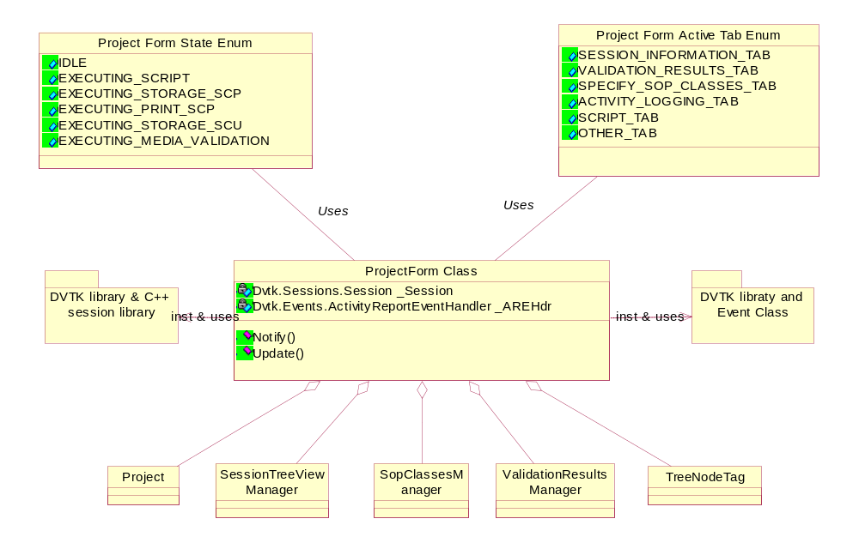
Figure 3 Class diagram of ProjectForm
This class contains following main member variables:
- It aggregates the Project class. By using this class it manages the project files (.pdvt) and the sessions files (.ses) in those projects. E.g. getting nr of session files in a project, closing/opening project files.
- It aggregates the SessionTreeViewManager class. By using this class it controls, updates tree view structure and its nodes. User can execute the scripts, emulator and media files by double clicking the tree nodes.
- It aggregates the SOPClassManager class. By using this class it displays the SOP class definitions and info in the data grid.
- It aggregates the ValidationResultsManager class. By using this class it validates the results and displays report in summary and detail format on Validation Result tab page.
- It uses the Events component of DVTK library for logging all the activity and other logging information.
- It uses Session class for containing the current session value, whatever node selected by the user in tree view.
- It uses TreeNodeTag class for containing the current node selected by the user in tree view.

This class contains following main member functions:
- Notify() operation used to notify an important UI event to MainForm class, which in turn will notify all available ProjectForm child forms.
- Update() operation used for updating TreeView control and Tab Control. It is invoked by Notify method when user changes the session/project info, executes the script etc.

SessionTreeViewManager Class
SessionTreeViewManager Class is very important class in the DVT tool. The important features of this class as described below:
- It manages the Tree view structure in the right pane of GUI.
- This class uses TreeNodeTag class that emulates the node of the tree structure. The tree node may be a session file (.ses), a script file (.dss/.ds/.vbs) or a result file(.res). All the derived classes from the TreeNodeTag represent the types of tree nodes.
- When the user double clicks a tree node (any emulator/media session or script node), the execution starts in the separate thread. After completion of execution, the results are notified to main thread asynchronously using Invoke method.
- This class implements all the event handlers and updates the tree view control, e.g. creation and manipulation of tree nodes.

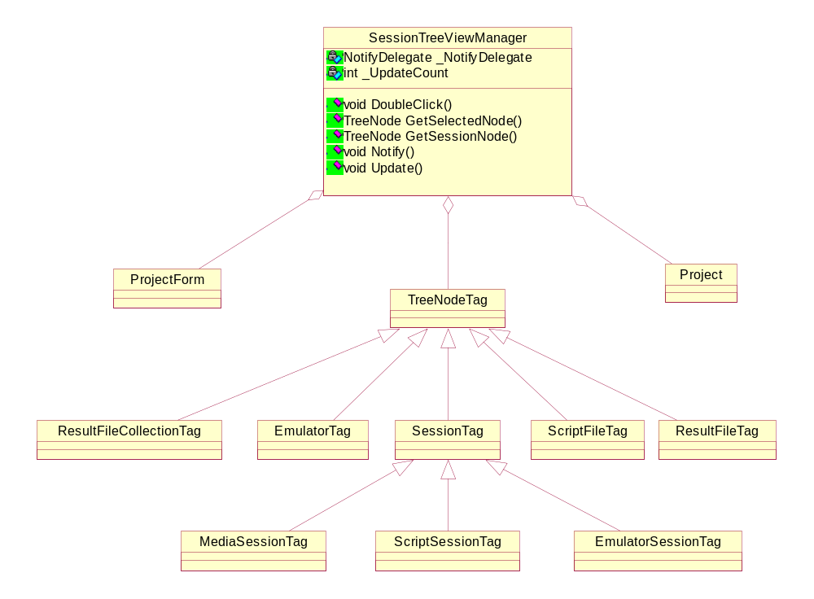
Figure 4 Class diagram of SessionTreeViewManager

A Brief description of various member variables defined as below:
- ProjectForm object is used to call Notify/Invoke methods and updates TreeView UI control in the ProjectForm class.
- Project object is used to get the nr. Of sessions in the project.
- NotifyDelegate is used to convey results to main thread after completion of execution.
- TreeNodeTag variable contains the currently selected TreeNode of TreeView control.
- Update count is used to avoid infinite looping that can be triggered due to user change and System changes.

The important member functions of this class are:
- DoubleClick() operation is the entry point for all double click action in the tree view control. Basically the value of selected node is stored and it checks whether the node is a MediaSessionTag, ScriptSessionTag, EmulatorSessionTag. Depending upon the type of TreeNodeTag, execution happens in different helper functions. The following table provides the clear idea of all the helper functions:

Type of TreeNodeTag | Function Name | Description
MediaSessionTag | DoubleClickMediaSessionTag | Uses System delegate AsyncCallback for notifying the results to Main Thread.
EmulatorSessionTag | ExecuteSelectedEmulator | It executes the different emulators e.g. Print SCP, Store SCP/SCU.
Dicom ScriptNode(.dss/.ds) | ExecuteDicomScriptInThread | Uses System delegate AsyncCallback for notifying the results to Main Thread.
VB ScriptNode(.vbs) | ExecuteVisualBasicScriptInThread | Uses Host script engine for executing VB script in a separate thread.

- GetSelectedNode() operation is called to get the user selected Tree Node.
- GetSessionNode() operation is called to get the session node, The session node may be of Emulator session, Media session or Script session.
- Update() method is called to update the Tree View control depending upon the event types.
- Notify() method is called for forwarding the events to ProjectForm.

SOP Class Manager Class
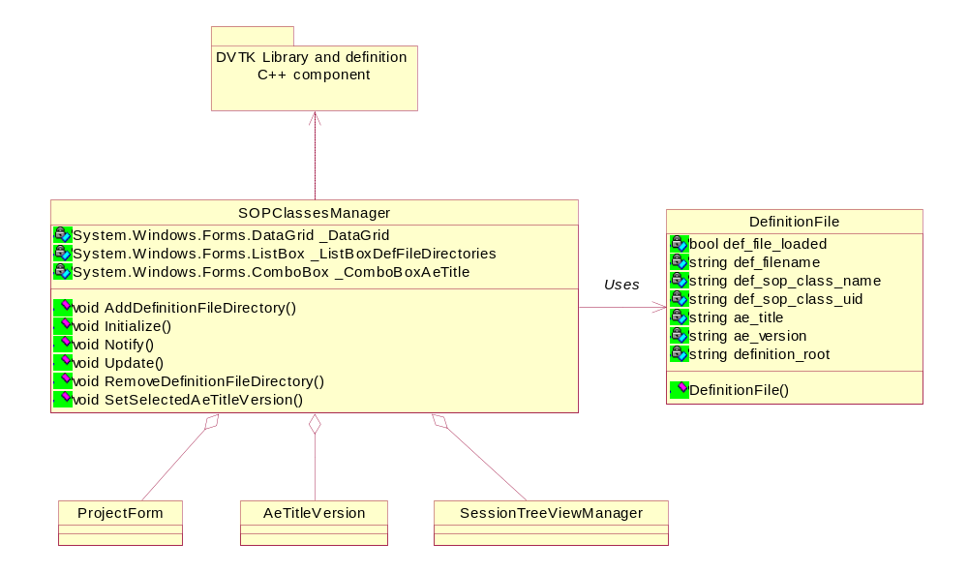
Figure 5 Class diagram of SOP Class Manager
This class handles visualization and selection of the SOP classes for a session on DataGrid. Firstly it reads the list of Definition file directories form the session file then it parses all definition files available in those directories. This class uses DefinitionFile class and DVTK library for parsing and getting all SOP classes information as shown in above class diagram. The user can add/remove the definition file directory and set the selected AE title, version.

A Brief description of various member variables defined as below:
- ProjectForm object is used to call Notify method and forwarding the events to the ProjectForm class. ProjectForm and MainForm class in turn updates all UI controls.
- SessionTreeViewManager object is used get the currently selected TreeNode.
- ListBox is used to contain the list of definition file directories.
- ListBox is used to contain the list of AE title and version combinitions.
- Default AE title and version is “DICOM-3.0”.

The important member functions of this class are:
- Add/Remove DefinitionFileDirectory() operation is called to add/remove the definition file directory in/from the current directory list.
- Initialize() method is called to construct the data grid with all the columns i.e. Def File Loaded, Def File Name, SOP Class Name, SOP Class UID, AE Title, AE version and Def Root.
- Update() method is called to update the Tree View control depending upon the event types.
- Notify() method is called for forwarding the events to ProjectForm.

ValidationResultManager Class

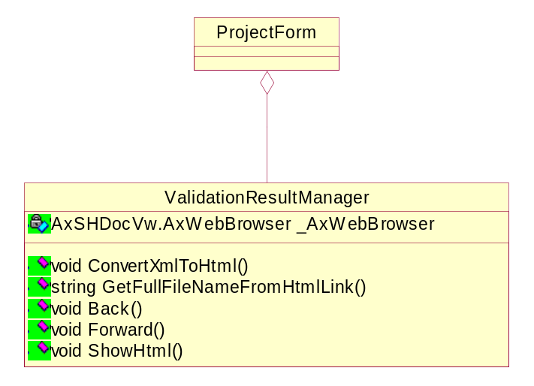
Figure 6 Class diagram Validation Result Manager

When user double clicks the any tree node for execution, the execution of emulator, media or script session starts. So one should call the following method for validation results gathering.

StartResultsGathering(theResultsFileName);

And after completion of execution, another method should be called for ending results gathering.

EndResultsGathering();

The gathered results are in XML format and for displaying the validation results should be converted to HTML format. The above class performs the same and displays the result (in summary/detail format) using style sheet. This class also provides wrapper around activeX web control for browsing result files.

A Brief description of various member variables defined as below:
- _AxWebBrowser represents the object of ActiveX control used as Web browser.
- _HTMLDocument represents the Html document that is currently shown.
- _HTMLBody represents the body of the Html document that is currently shown.
- _FindRemainingText represents the remaining text part of the displayed Html.

The important member functions of this class are:
- ConvertXmlToHtml() operation converts a XML file into a HTML file.
- ShowHtml() method is used to show Html link.
- CommandStateChange() method handles the command state change, to determine if the Back and Forward are enabled or disabled.
- GetFullFileNameFromHtmlLink() method gets the full file name form Html link.

ResultsFile Class
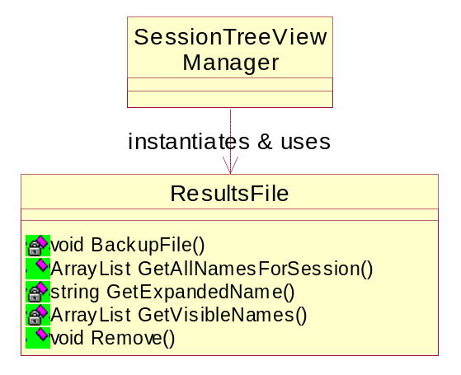
Figure 7 Class diagram of ResultsFile

This class manages the validation result files. The user can take back up of previous results and also remove old result files. The SessionTreeViewManager class instantiates and uses this class for results file management.

The important member functions of this class are:
- BackupFiles() operation takes the back up of previous results files.
- Remove() method is used remove .xml files, and if exisiting, the corresponding .html files.
- GetNamesForCurrentSessionId() method returns those results file names with the same session ID as the session ID of the supplied session.
- GetVisibleNamesForSession() method gets the results file names of the files that need to be shown (in)directly under the tree node indicated by the tree node tag.
- GetNamesForScriptFile() method gets the results file names for a script file of the files that need to be shown (in)directly under the tree node indicated by the tree node tag.
- GetBaseNamesForResultsFiles() method gets the base names from a list of results file names.
- GetAllNamesForSession() method gets all the results filenames under a session.

Project Class
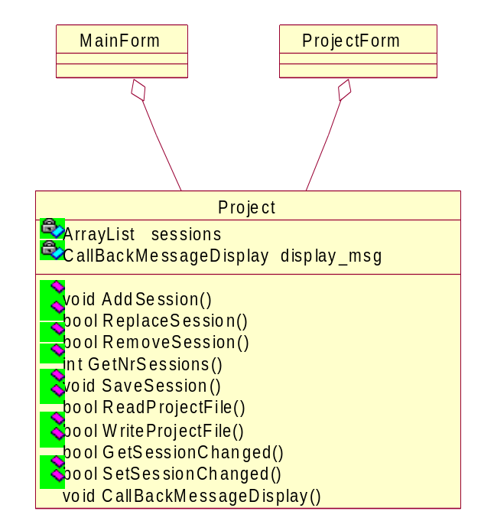
Figure 8 Class diagram of Project

This class manages the project file and sessions under it. The project file is a XML file and contains all session files information in it. It adds, removes and save sessions by using DVTK library session class. It also manipulates the project file using XML writer class.
The important member functions of this class are:
- AddSession() operation is called to adding the session to project.
- LoadSession() operation is called to load the session.
- RemoveSession() method is called to removing the session from project.
- SaveSession() method is called for saving the session.
- SaveSessionAs() method saves the session under a new file name.
- GetNrSessions() method is called for getting nr. of sessions in the project.
- SaveProject() method saves the Project to the specified Project file name.
- Load() method loads the project in DVT GUI.
- New() method is used construct a new empty Project that has not been saved yet to the supplied Project file.

EventType Class

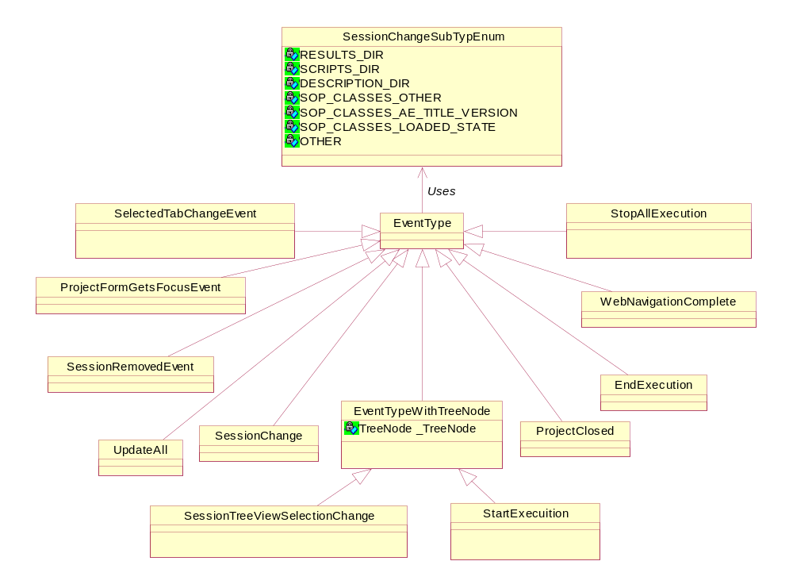
Figure 9 Class diagram of Event Type

This class represents all types of events and each derived class represents one event type. If user performs some actions on the UI, the event will be fired and notified to ProjectForm and MainForm. Then both forms will update all the UI controls depending on the type of event. For example SessionChange event will be fired when user changes one of the following things:
- Results directory
- Scripts Directory
- Description directory
- AE title version
- Any changes in SOP class definition

WizardNew Class

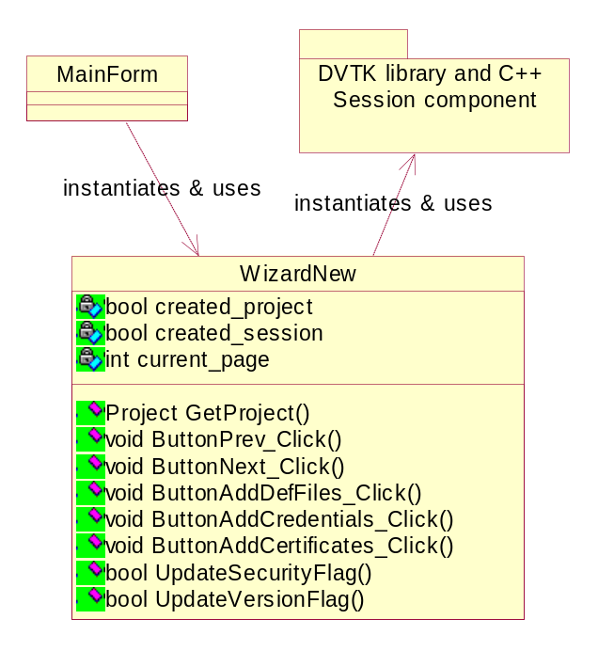
Figure 10 Class diagram of WizardNew

This class emulates the Wizard and instantiated by the MainForm. When user wants to create a new project/session, it pops up the various pages. User can browse through the pages using next/back button and provides the necessary information. The user will view the following pages:
- When user clicks the new from the File menu, the selection window appears for creating the new projects/sessions or adding existing sessions.
- After pressing next button, the session properties dialog displays. The user should provide session info e.g. Type of session media/script/emulator, Session title, Date, Tested by.
- In the next form, the user should provide DVT role settings (AE Title, listen port, Socket-Time out, Maximum PDU Length).
- After pressing next button, provide System Under Test (SUT) settings (AE Title, Listen port, Maximum PDU Length and options like using insecure option port).
- In the next form, fill environment settings (i.e setting path for Definition File Directory, Result File Directory, Script directory).
- In next form provide definition files info.

Finally after a series of steps, the ProjectForm pops up and displays all the information mentioned above.

CustomExceptionHandler Class
This class handles the exception events raised.

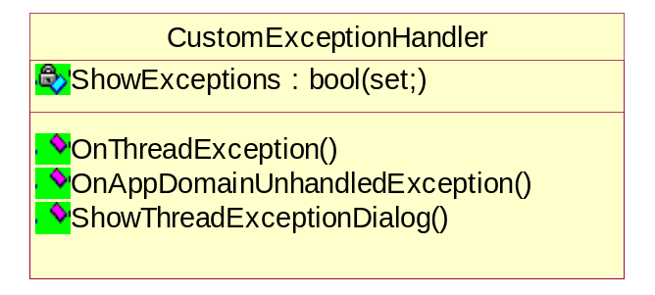
Figure 11 Class diagram of CustomExceptionHandler
The important member functions of this class are:
- OnThreadException() operation is called to catch the threading exceptions.
- OnAppDomainUnhandledException() operation is called to catch all the unhandled exceptions.
- ShowThreadExceptionDialog() method is called to display a dialog to user.

UserSettings Class
This class represents the User settings of DVT. The settings may be loaded and saved to the setting file in the application data folder of the logged in User.
The actual settings are:
- Ask for Backup results file
- Show Empty Sessions
- Show DicomScripts
- Show DicomSuperScripts
- Show VisualBasicScripts
- Expand VisualBasicScript

A Brief description of various properties defined as below:
- AskForBackupResultsFile:bool(get; set;)
This property indicates if DVT should ask to backup the results file before removing/overwriting it.
- ShowEmptySessions:bool(get; set;)
This property indicates of DVT must show empty sessions.
An empty session is a script session containing no visible scripts.
- ShowDicomScripts:bool(get; set;)
This property indicates if .ds files must be visible in a script session.
- ShowDicomSuperScripts:bool(get; set;)
This property indicates if .dss files must be visible in a script session.
- ShowVisualBasicScripts:bool(get; set;)
This property indicates if DVT should ask to backup the results file before removing/overwriting it.
- ExpandVisualBasicScript:bool(get; set;)
This property indicates, when displaying a .vbs file, if the #include statements must be expanded.

The important member functions of this class are:
- Load() operation loads the User settings from the setting file.
- Save() operation saves the User settings to the setting file.
- ReadBoolean() & WriteBoolean() methods are called to read/write boolean to the setting file.

NodeInformation Class
This class contains extra information on the nodes in the Session Tree.

The important member functions of this class are:
- StoreExpandInformation() operation stores information on which nodes (the supplied node and all sub nodes) are expanded.
- RestoreExpandInformation() operation expands the supplied node and sub nodes back if they were expanded before.
- RemoveExpandInformationForSession() method removes all expanded information for the supplied session.
- StoreSelectedNode() method stores information on selected node.
- RestoreSelectedNode() method selects the node with the same representing tag.

PathUtils Class
This class adds extra methods concerning paths not present in the .NET Path class.

The important member functions of this class are:
- IsRelativePath() operation returns a boolean indicating if the path is relative.
- ConvertToAbsolutePath() operation converts a relative path to an absolute path.

DVT Command Tool
This tool is a command prompt version of DVT GUI. Currently, the user can execute only scripts (.ds, .dss or .vbs) sessions but in future extensions to this tool support of emulator and media session can also be provided. Table given below shows the various options provided by the tool:

Options | Arguments | Description
-t (optional) | <Full session file name>, <Full script file name> | The user can execute the script (.ds, .dss, .vbs) by providing both arguments with/without mentioning option.
-c | <Full script file name> | The user can compile only the VB script. The compilation errors with line number will be displayed on the command window.
-v | No arguments | Detail verbose logging will be displayed on the command window.
-h | No arguments | Help info will be displayed on the command window.

The advantage of this tool is that user can execute all the script files exist in a session using a batch file.

Design of DVT command tool

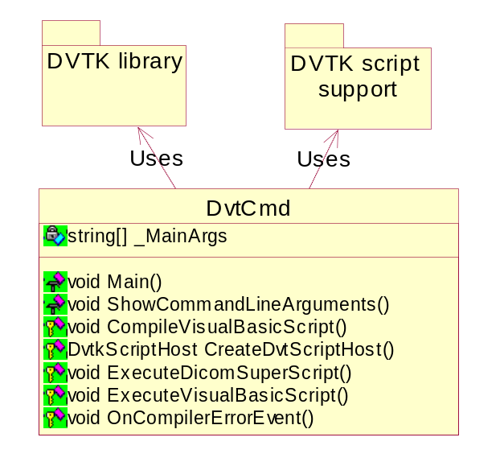
Figure 12 DvtCmd class diagram
The important member functions of this class are:
- Main() is the entry point of the DVT command application. It stores the argument list provided by the user in member variable _MainArgs.
- ShowCommandLineArguments() method displays the help information.
- CreateDvtScriptHost() method uses the DVTKScriptSupport component to create the script host to execute/compile VB script.
- CompileVisualBasicScript() method is called when user wants to compile the VB script. The compilation error will be displayed on the command window.
- OnCompilerErrorEvent() method is a event handler and called from the script host engine whenever it comes across some compilation error in the VB script. The error string/line number is passed on to DvtCmd class for displaying.
- ExecuteDicomScript() method executes Dicom(Super)Script in the main thread and saves the result file in the directory mentioned in the session file.
- ExecuteVisualBasicScript() method executes VB Script in the main thread and saves the result file in the directory mentioned in the session file.

